Symbolism Notes
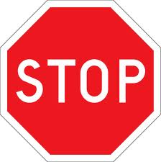
What can be a symbol: an ____________, picture, written ___________, sound, _____________, language
Different kinds of symbols all around us:
-_____________ symbols
-_____________ symbols (country’s flags, etc.)
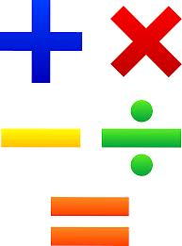
-_____________ symbols ( X, %, +, -, =)
- colors (green = go, etc.)

~~~~~~~~~~~~~~~~~~~~~~~~~~~~
Symbolism in Writing
-Symbolism is used to provide _____________________ to the writing beyond __________________________________________________________________
- __________________ and ___________________ are one level of the story; ___________________ is another level
Examples:
-a storm occurring might represent (SYMBOLIZE) ____________________ or _________________ __________________
-transitioning from day to night might be moving from _____________ to ______________

